LOCATORS AND OBJECT IDENTIFICATION
Course: Selenium Web Automation Training
Module / Week: Week 1 Assignment

1. DISCUSSION ON CHALLENGES AND COMPLEX WEB ELEMENT LOCATOR IDENTIFICATION
A Web Element Locator is used in Selenium to identify and interact with web elements such as: Text boxes, Buttons, Links, Checkboxes, Dropdowns, Images.
Common locators include: ID, Name, Class Name, Tag Name, Link Text, Partial Link Text, CSS Selector, XPath
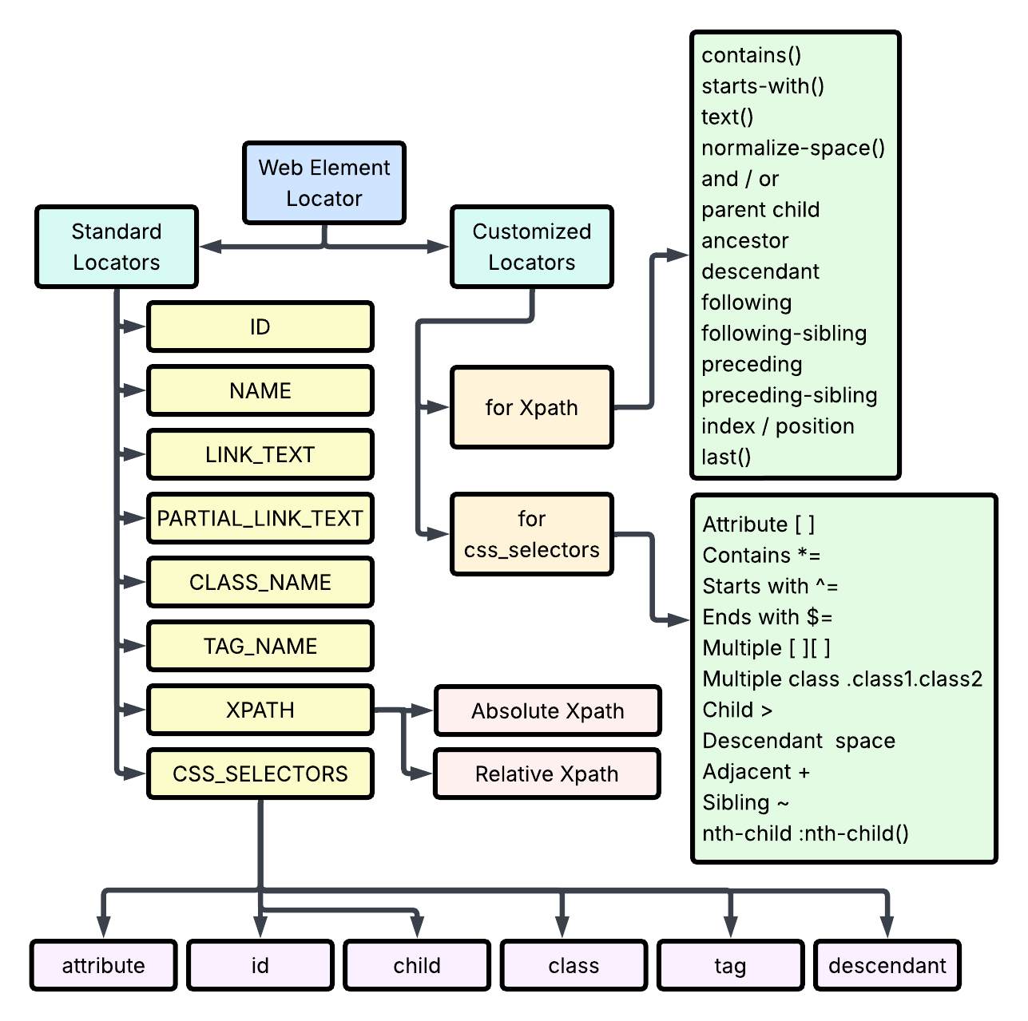

Challenges in Identifying Complex Web Elements

1.Dynamic IDs and Attributes:

Some websites generate IDs dynamically. (<input id="user_12345">).The ID may change every time the page loads like (user_12345, user_67890, user_98765). In such cases use a stable attribute or dynamic XPath/CSS selector.

2.Dynamic Web Elements:

Some elements appear after the page has loaded. Selenium may try to locate the element before it is available. In this case use Explicit Wait to solve the problem.
from selenium.webdriver.support.ui import WebDriverWait
from selenium.webdriver.support import expected_conditions as EC

3. Multiple Similar Elements
A webpage may contain multiple elements with the same class.
<button class="btn">Login</button>
<button class="btn">Register</button>
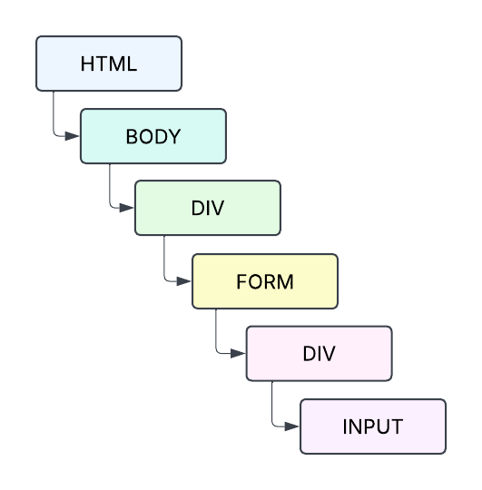
The locator may identify the wrong element. In this case use a more specific XPath or CSS Selector to solve any conflict.

4. Nested Elements
Complex webpages may contain deeply nested HTML elements. Finding the exact element becomes difficult. In this case use relative XPath or CSS selectors.

5. Iframes
Some elements are located inside an iframe. Selenium cannot directly access elements inside an iframe. First switch to the iframe, then work on it. driver.switch_to.frame("frame_name")

6. Shadow DOM
Modern web applications may use Shadow DOM. Normal locators may not directly access elements inside the Shadow DOM. Access the Shadow Root first and then locate the element.

7. Hidden Elements
Some elements exist in the HTML but are not visible to the user. Selenium may locate the element but cannot interact with it. Wait until the element becomes visible or clickable.

2. UNDERSTANDING ELEMENTS, FIND ELEMENT BY ID AND NAME

To interact with a webpage using Selenium, the script first needs to locate the HTML components it wants to control. In the underlying document structure, these components are called WebElements.
The Finding Mechanism:
The Selenium webdriver component provides two primary methods to locate elements on a page:
findElement(): Searches the page and returns a single webelement If it finds multiple elements matching your criteria, it simply returns the very first one it encounters in the HTML tree. If no matching element is found, it throws a NoSuchElementException.
findElements(): Searches the page and returns a List/Array of webelements. If no elements match, it returns an empty list instead of throwing an error. This is useful for counting items or iterating through tables.
- Locating by ID (By.ID)
The ID attribute is universally considered the most efficient and reliable way to locate an element. Per W3C web standards an id attribute is supposed to be unique within an HTML page. This means in the script user can instantly target the element without worrying about accidental matches elsewhere on the screen.
Example:
HTML code is
<input type="text" id="user-email" placeholder="Enter your email">
# Python
From selenium.webdriver.common.by import By
email_field = driver.find_element(By.ID, "user-email")
email_field.send_keys("test@example.com")

- Locating by Name (By.NAME)
The Name attribute is commonly found on form fields (like text boxes, radio buttons, and checkboxes) because backend servers use the name attribute to process submitted form data. Unlike IDs, name attributes are not guaranteed to be unique. For example, a group of radio buttons will all share the exact same name attribute to group them together.
Example:
HTML code is
<input type="password" name="security_password" class="input-box">
# Python
password_field = driver.find_element(By.NAME, "security_password")
password_field.send_keys("Secret123!")

3. BY TAG NAME, LINK TEXT, AND CLASS NAME

- Locating by Tag Name (By.tagName)
The Tag Name refers to the actual HTML element type (<h1>,<a>,<input>,<button>,<div>).
Because a typical webpage contains dozens or hundreds of identical HTML tags, using findElement(By.tagName) will only return the very first tag of that type found in the document tree. Therefore, this strategy is almost exclusively used alongside findElements() to extract lists of similar items.
Common Use Cases:
- Counting the total number of links (<a> tags) on a page.
- Extracting text from all table rows (<tr> tags).
- Gathering all input text fields in a form to clear them.
Example:
HTML code is
<h1>Welcome to the Dashboard</h1>
# Python: Extract the text from the main header
page_header = driver.find_element(By.TAG_NAME, "h1")
print(page_header.text) # Outputs: Welcome to the Dashboard

- Locating by Link Text (By.linkText & By.partialLinkText)
This strategy is specifically designed to find hyperlinks (anchor <a> tags) based on the visible text displayed on the screen.
By.linkText: Requires an exact match of the link text, including casing, spaces, and hidden characters.
By.partialLinkText: Looks for a substring match. It is ideal for long links or links that contain dynamic numbers (e.g., matching "Order #12345" by just searching for "Order").
Example:
HTML code is
<a href="/settings/profile">Manage Account Settings</a>
# Python (Exact Match)
exact_link = driver.find_element(By.LINK_TEXT, "Manage Account Settings")
exact_link.click()

# Python (Partial Substring Match)
partial_link = driver.find_element(By.PARTIAL_LINK_TEXT, "Account Settings")
partial_link.click()
- Locating by Class Name (By.CLASS_NAME)
The Class Name targets elements styled with specific CSS classes. Web designers use classes to apply identical layouts across multiple items. Because classes are fundamentally designed to be shared, class attributes are rarely unique.
Compound Classes
Selenium's By.className method does not accept spaces. If an element has multiple CSS classes listed in its attribute (known as compound classes), passing the full string into By.className will throw an InvalidSelectorException. Just one of those individual classes must be used.
Example:
HTML code is
<!-- This element has two classes: "btn" and "btn-success" -->
<button class="btn btn-success">Submit Payment</button>
#Python
# WRONG: This will throw an error due to the space
submit_btn = driver.find_element(By.CLASS_NAME, "btn btn-success")
# CORRECT: Choose just one of the unique class names
submit_btn = driver.find_element(By.CLASS_NAME, "btn-success")
submit_btn.click()

- FIND LIST OF ELEMENTS (`find_elements`)

To interact with a webpage using Selenium, the script first needs to locate the HTML components it wants to control. In the underlying document structure, these components are called WebElements.
The Finding Mechanism:
The Selenium webdriver component provides two primary methods to locate elements on a page:
findElement(): Searches the page and returns a single webelement If it finds multiple elements matching your criteria, it simply returns the very first one it encounters in the HTML tree. If no matching element is found, it throws a NoSuchElementException.
findElements(): Searches the page and returns a List/Array of webelements. If no elements match, it returns an empty list instead of throwing an error. This is useful for counting items or iterating through tables.
Example:
HTML code is
<ul class="nav-menu">
<li class="menu-item">Home</li>
<li class="menu-item">Products</li>
<li class="menu-item">Contact Us</li>
</ul>

#python

from selenium.webdriver.common.by import By

# Find all items matching the class name
menu_items = driver.find_elements(By.CLASS_NAME, "menu-item")

# Print the total count
print(f"Total menu items: {len(menu_items)}")

# Loop through the list to extract text
for item in menu_items:
print(item.text)

5. BY CSS, USING WILDCARDS WITH CSS SELECTORS, CHILD NODES

CSS Selectors provide high-speed, powerful, and flexible element identification.
- Basic CSS Selectors (By.CSS_SELECTOR)
Before diving into wildcards, here is how standard HTML attributes translate into basic CSS selectors:
- ID Selector (#): Targets an element by its ID attribute.
HTML: <input id="username"> CSS Selector: #username
- Class Selector (.): Targets elements by their class attribute.
HTML: <div class="card"> CSS Selector: .card
- Attribute Selector ([ ]): Targets elements matching a specific attribute name and value.
HTML: <input type="email"> CSS Selector: input[type='email']
B. Using Wildcards With CSS Selectors
Wildcards allow user to match partial string values. This is incredibly useful for modern web frameworks (like React or Angular) that generate dynamic IDs or classes where only a part of the text remains constant. Selenium supports three primary wildcard symbols in CSS selectors:
Wildcard | Meaning | Match Type | CSS Syntax Example | Matches
^= | Starts With | Prefix match | input[id^='user_'] | user_abc, user_123
$= | Ends With | Suffix match | input[id$='_submit'] | login_submit, btn_submit
*= | Contains | Substring match | input[id*='btn-pay'] | my-btn-payment-now, btn-pay-1
C. Locating Child Nodes Using CSS Selectors
To navigate down the HTML tree from a parent container to its children, CSS selectors use relationship combinators.
- Direct Child Operator (>)
Finds elements that are immediate children of the parent element. It will not look further down into nested sub-elements.
Example:
HTML code is
<div id="parent-box">
<p>Direct Child Paragraph</p> <!-- MATCHES -->
<div>
<p>Nested Grandchild Paragraph</p> <!-- WILL NOT MATCH -->
</div>
</div>
CSS Selector: div#parent-box > p
- Sub-Child / Descendant Operator (Space )
Finds any matching element anywhere inside the parent container, no matter how deeply nested it is (children, grandchildren, etc.).
Using the same HTML above:
CSS Selector: div#parent-box p (Both paragraphs will be matched).

- Nth-Child Structural Pseudo-classes (:nth-child())
If a parent has a list of identical children, you can target a specific one by its mathematical index (starting at 1).
First child: ul#menu > li:first-child
Last child: ul#menu > li:last-child
Specific index (e.g., 3rd item): ul#menu > li:nth-child(3)

- Adjacent Sibling Combinator (+)
Selects the immediate next sibling element that sits directly after the first element, sharing the same parent.
Syntax Pattern: Element1 + Element2
Example:
HTML code is
<form>
<label for="username">Username:</label>
<input type="text" id="username"> <!-- MATCHES! Directly follows label -->
<input type="text" id="extra-field"> <!-- Does NOT match -->
</form>
# python
# Finds the input box directly following the label
element = driver.find_element(By.CSS_SELECTOR, "label[for='username'] + input")
element.send_keys("MyUsername")

- General Sibling Combinator(~)
Selects all subsequent elements that come after the first element under the exact same parent, even if they are not directly next to it.
Syntax Pattern: Element1 + Element2
Example:
HTML code is
<div>
<h2>Main Section Title</h2>
<span class="author">By John Doe</span>
<p>This is the 1st paragraph.</p> <!--MATCHES! Comes after h2 under same parent -->
<p>This is the 2nd paragraph.</p> <!--MATCHES! Comes after h2 under same parent -->
</div>
# Python:
# Finds ALL paragraph tags that follow the h2 tag
paragraphs = driver.find_elements(By.CSS_SELECTOR, "h2 ~ p")
print(f"Found {len(paragraphs)} paragraph elements.")

